Essay

Link for the piece : https://www.youtube.com/watch?v=nGD-vqQI_5M

The main inspiration of our composition is the sleep cycle and the ability of dreams to distort strangely familiar events or impressions, making us face the unknown. The listener will be led through the piece by a “guideline”, a familiar melody which either drifts apart or gets clearer, similar to the changes in the awareness of a sleeper.

The goal of the piece is to bring a reflection about what music is, especially by blurring the line between music, sound and noise. This idea is very related to the theme of consciousness and the loss of marks in our composition. In fact we try to take the listener out of himself into a journey in a sleep. We will go through different phases following the sleep cycle by modifying our guideline melody, adding some ambient noises and creating several atmospheres through the piece.

To do so, we chose to edit “Für Elise” from Beethoven, as the melody is easily recognizable and quite repetitive : we aim to place our audience in a comfortable and a bit passive mind set, so that when we will pull them out of this state of mind we will create even more contrast and awkwardness.

As our composition follows a coherent outline, it will start with an “Awake” phase, which is used for introducing the base idea of the piece and representing a clear state of mind. The melody is first played there and ambient noises highlight a kind of “audio story” concept. It aims to give references to our listener and to keep him focused on the structure of the piece.

Then comes the “Light sleep”, which represents a calm and neutral sleep, yet submitted at some inconsistencies where we seek to confuse the listener. In this phase the melody is dampened with quieter and lower pitches, and a darker timber is selected to create a calming mood. With a view to confuse we will add a light echo within reason.

Starting from there the outline becomes partially random and the “REM sleep”, “Light sleep” and “Deep Sleep”phases succeed according to the sleep cycle data. At the end of the piece an alarm rings, which marks a funny contrast with the nightmare, pulling the listener out of his thoughts into a mundane reality.

The “Deep sleep” is the slowest and deepest phase of the sleep, that’s why we want it to evoke a loss of control and references. Thus we blur the melody through polyrhythms, microtones, or a switch in binary for instance. By adding sound effects such as a long reverb, an echo and pitch-shifters, everything comes together into one sound and the listener doesn’t have anything left to concentrate on, simulating the rest and total loss of awareness experienced while being in deep sleep.

The “REM sleep” is at the opposite the most conscious and wildest period of the sleep, when dreams happen. Therefore we want the listener to be active, trying to work out what he hears, and finally to have him left with a lot of impressions to digest. In this way we are going to clarify the melody, add supporting melodies. Strong emotions will be expressed to figure a nightmare : slower and muddled pitches with a reverb effect to depict sadness, and clear and loud pitches doubled with a faster rhythm to symbolize anger.

Our composition tries to explore the bounds of our usual mind set, and try to describe the transition from a “nominal” psychological state to a twisted one, here during a dream. This idea was already addressed by Fausto Romitelli in *Professor Bad Trip*, but in the context of a psychedelic experience.

At this point we already want our composition to be a coherent audio story, made by editing *Für Elise*’s score with algorithms to convey new emotions. The impressions depicted are going to follow the general structure of a sleep : a high-level algorithm will determine how to edit the sheet to suit the sleep data from a study on sleep cycles. This allows us to both have a certain freedom in our composition (compared to audio editing only) and to stay close enough from the original melody to play with the feeling of deja-vu and the stangness of its distortion. In addition we use audio editing to make the outline coherent and create a singular and cloudy atmosphere.

At first we had to generate the base outline of the piece, to set what feeling or impression is going to be conveyed at a given moment. In order to depict the sleep cycles we pass through during the night, we based ourselves on a study (cf. *Generation of the structure* in the notebook) which gives us data for the probability of every sleep phase to occur after a certain time past sleeping. We use this data as weights for a randomizer to build a sequence of sleep phases which matches well with the reality, as shown below.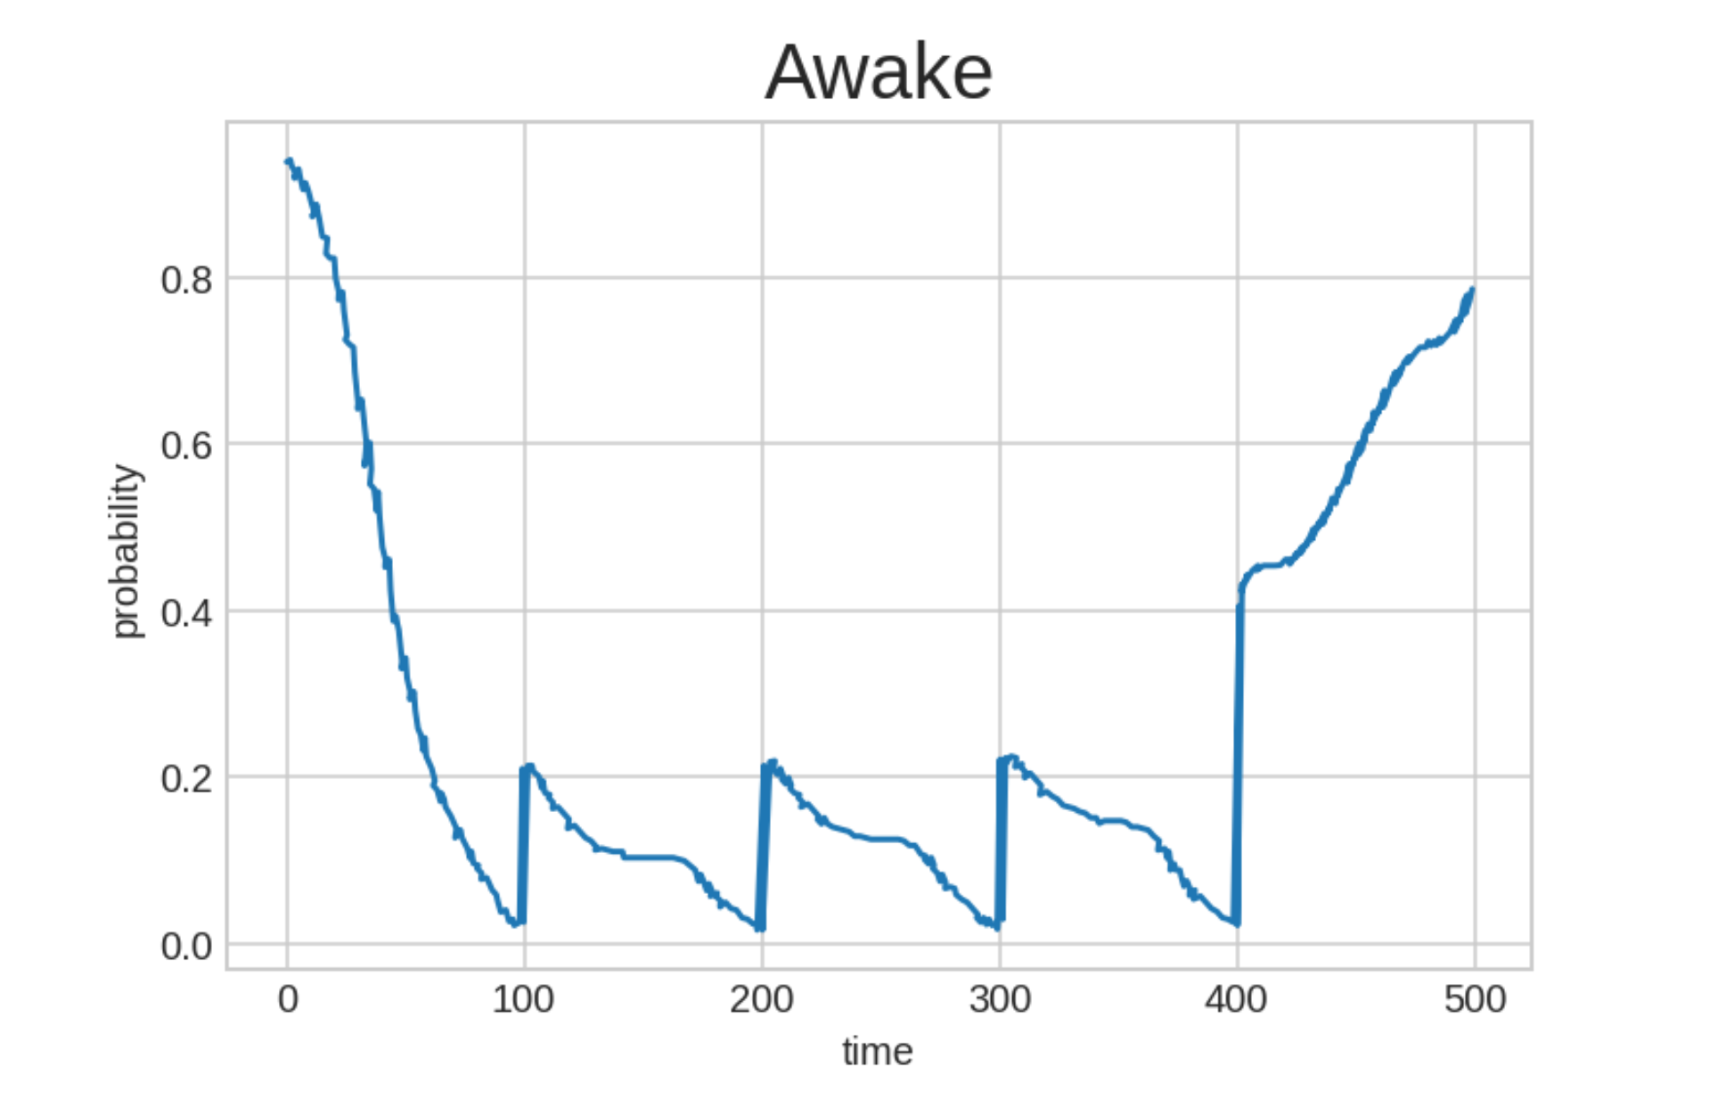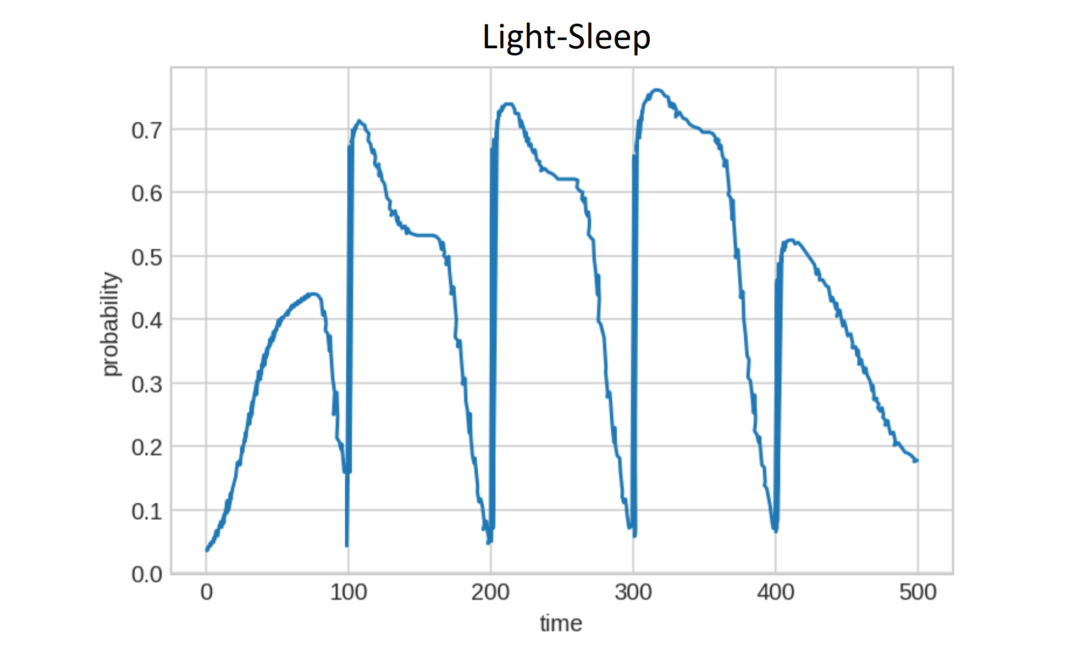

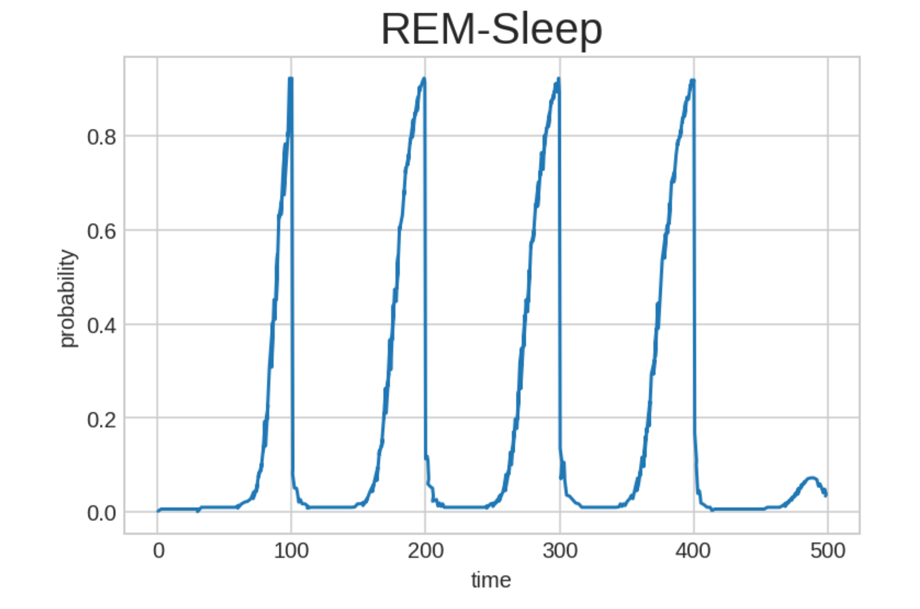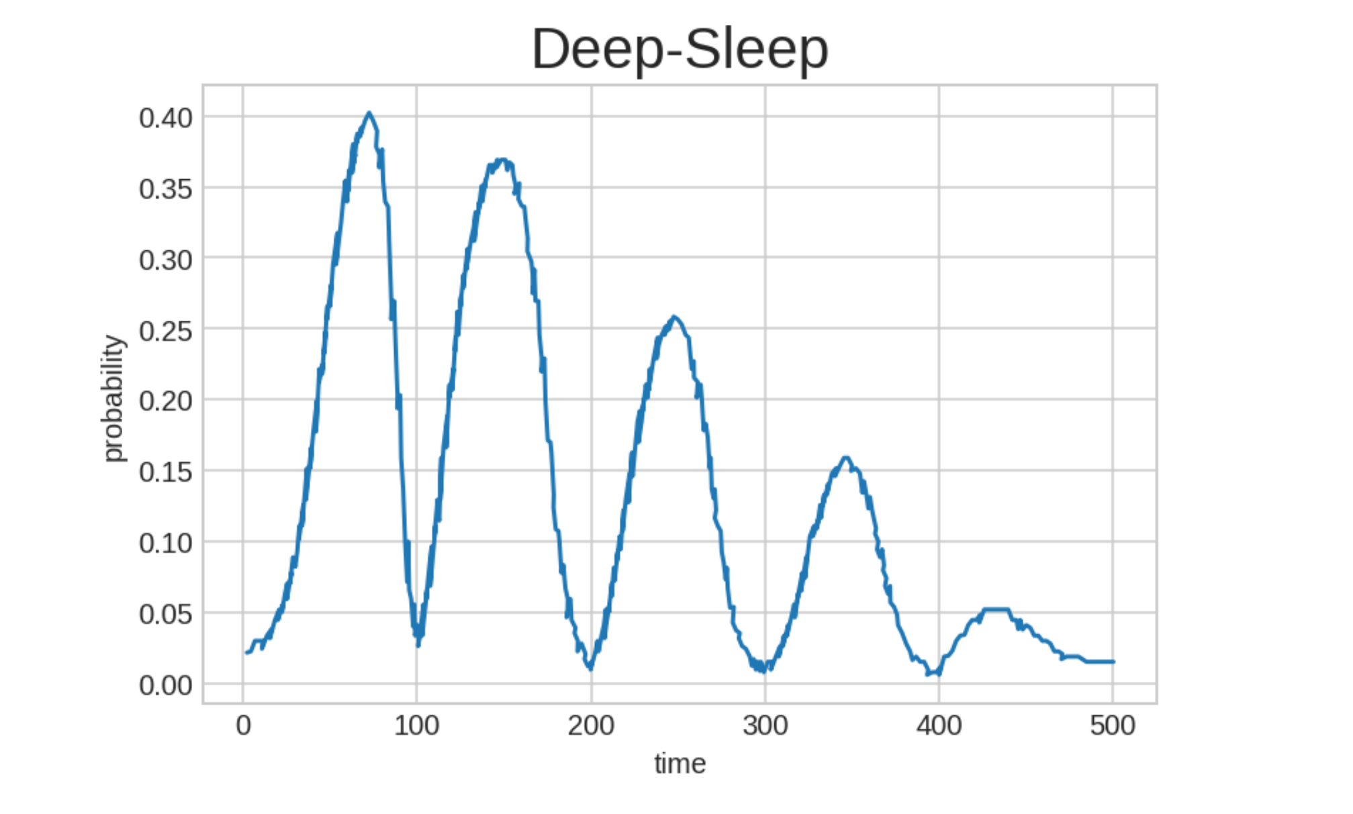

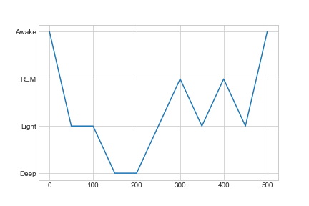

Final structure of the piece

This is quite close to what we expected first : a fall into a deep sleep at the beginning and then cycles of REM, even though it's a short version so that the piece is not too long.

In order to transform an abstract notion of sleep phases into a music work, we need each phase to be associated with different feelings or emotions as explained above, thanks to a couple of “editing functions”. Those ones allow us to perform a wide range of alterations, such as change the speed (Fig. 1), add new support voices (Fig. 2), add a drone (Fig. 3), add dynamism at some moments (Fig. 4) and various other functions such as the change of instrument etc... that are described in the notebook.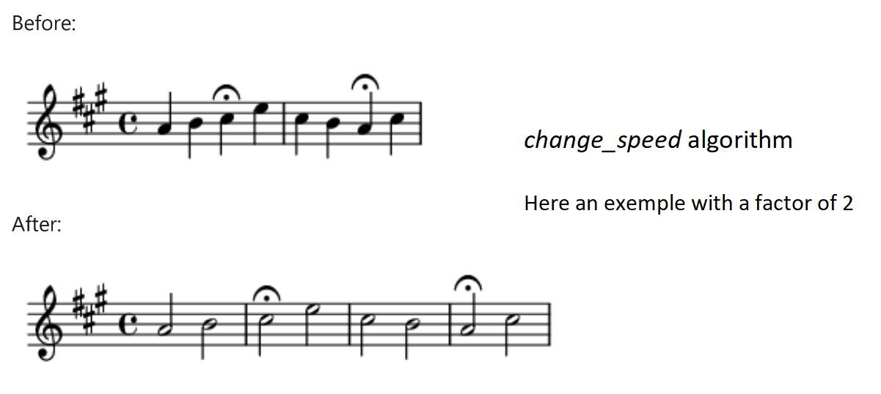

Fig. 1

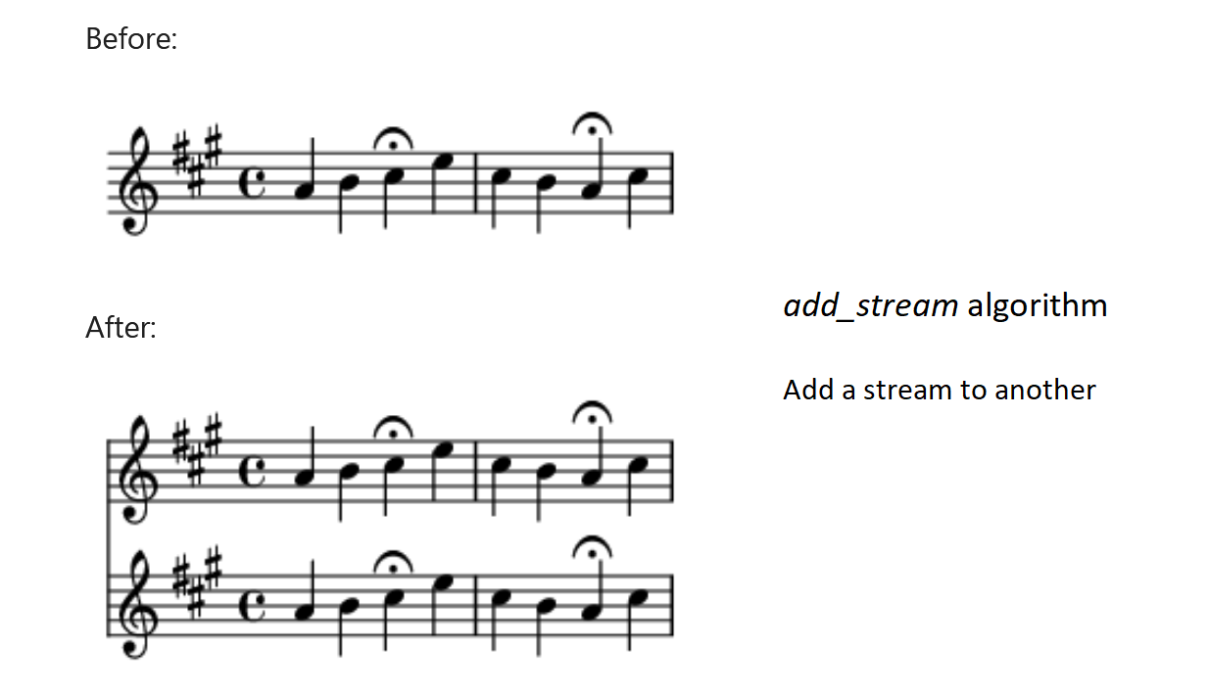

Fig. 2

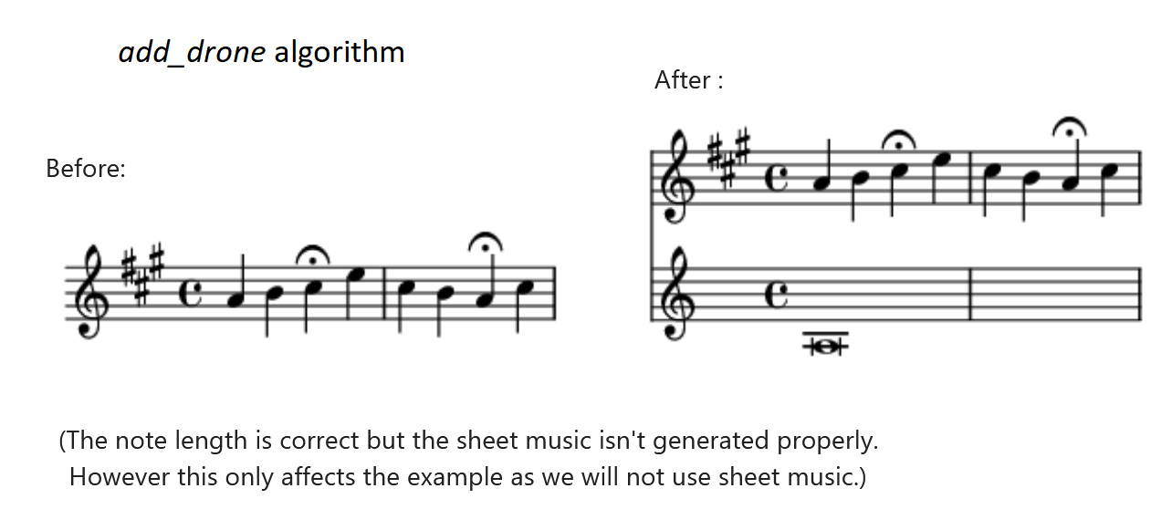

Fig. 3

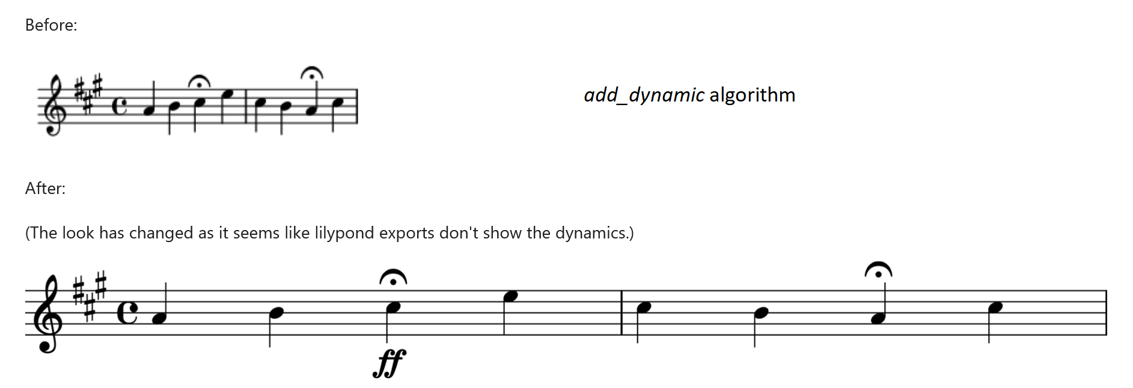

Fig. 4

That gives us material to build our sleep phases (Awake, Light-sleep, Deep-sleep and REM-sleep).

Our piece starts and ends “being awake” : in this introduction to our composition we set the scene and the spirit of the piece, using ambient sounds in addition to the melody. The latter was modified and has supporting melodies progressively added such as the left hand on a piano or a sequence of chords. The closer to falling asleep the more melodies there are. There is also a play on sounds that has two layers of understanding : if we tell a story of someone falling asleep, we also introduce a symbolism behind it, like in cinema. For instance the train sound figures the beginning of an imaginary trip, and the “door noise” with the echo marks the entry in the world of dreams and subconscious. AT the end the character is pulled out from his dreams by a long and obsessive alarm, ending the piece in a funny touch. For this part it was easy to control the outputs and the result is pretty close to the cinematographic view we had in mind.

The light sleep phase is more or less a transition phase where the body relaxes. We want to give this impression of relaxing and falling asleep by starting to lower the pitches, slow down the piece and make it quieter (dynamics) through our functions, while different effects we may want to add as well will be added later with the help of an audio editor. After some tests we produced a melody with a very regular rhythm which softens our attention and drags us into a sleep. This regularity also evokes a fixed idea, reminding us of fever dreams or a kind of madness. This concept came to us during tests, and we intended to deal with it while preserving a balance with our original ideas. The final output suits us.

In the REM sleep phase humans tend to dream, so we have here the greatest freedom on how to change up our main piece. We decided to represent the dreams by their emotions and trend to get away from the original score at some points, yet staying coherent, to play with the feeling of deja-vu. In our work we used the functions to represent stress mixed with anger : the dynamics are set to “fortissimo” (using *add_dynamics*) to create a loud part and the whole section is sped up (using *change_speed*) to create a sense of urgency, leading to stress. The anger is figured by the support voices, whose rhythmic pattern eclipses the melody at some point. The hammering of these regular and loud notes evokes outbursts of anger. We decided to give up on the idea of changing emotions while being in REM sleep because it adds too much confusion, but we may extend the range of emotions that the algorithm can convey each time he steps into the REM phase.

During the deep sleep, the listener should feel very far from being awake and lost in the music. We may remove the accompanying instruments and the melody will sound distant and will diverge from the original score. To achieve this goal we will slow the piece down significantly (using *change_speed*), add a lot of variation to the pitches (using *random_move_pitches*), play the pitches an octave lower (*move_pitches*) and add strong reverb or echo effects to create a sense of infinite space. But most of all, we take the freedom to get away from the original score and to have some repeated dissonant notes, which gives to the listener the impression to lose himself in inconscience. We also planned to add a drone note in the bass for improving stability, so that the listener will not feel totally lost, but we discarded this idea because we chose to confuse our listener.

Now the way we’re going to combine our sub-units looks quite clear : we will generate the general structure (refer to above for the visualization), then we will twist each phase with the appropriate algorithms to produce the final composition. The transitions between the phases need to be taken into consideration so that there are no abrupt changes which would destroy the harmony that we try to create. This will be handled by hand : we generate separate audio files for each phase, then we mix together the two phases involved ourselves.

Our graphical representation is a plot of the structure of the piece, as shown below. The colors represent the phase of sleep described in function of time. We chose this approach because a score or piano roll of our composition doesn’t let us imagine the feelings behind distortion, and it would be too hard to distinguish from the one of *Für Elise*.

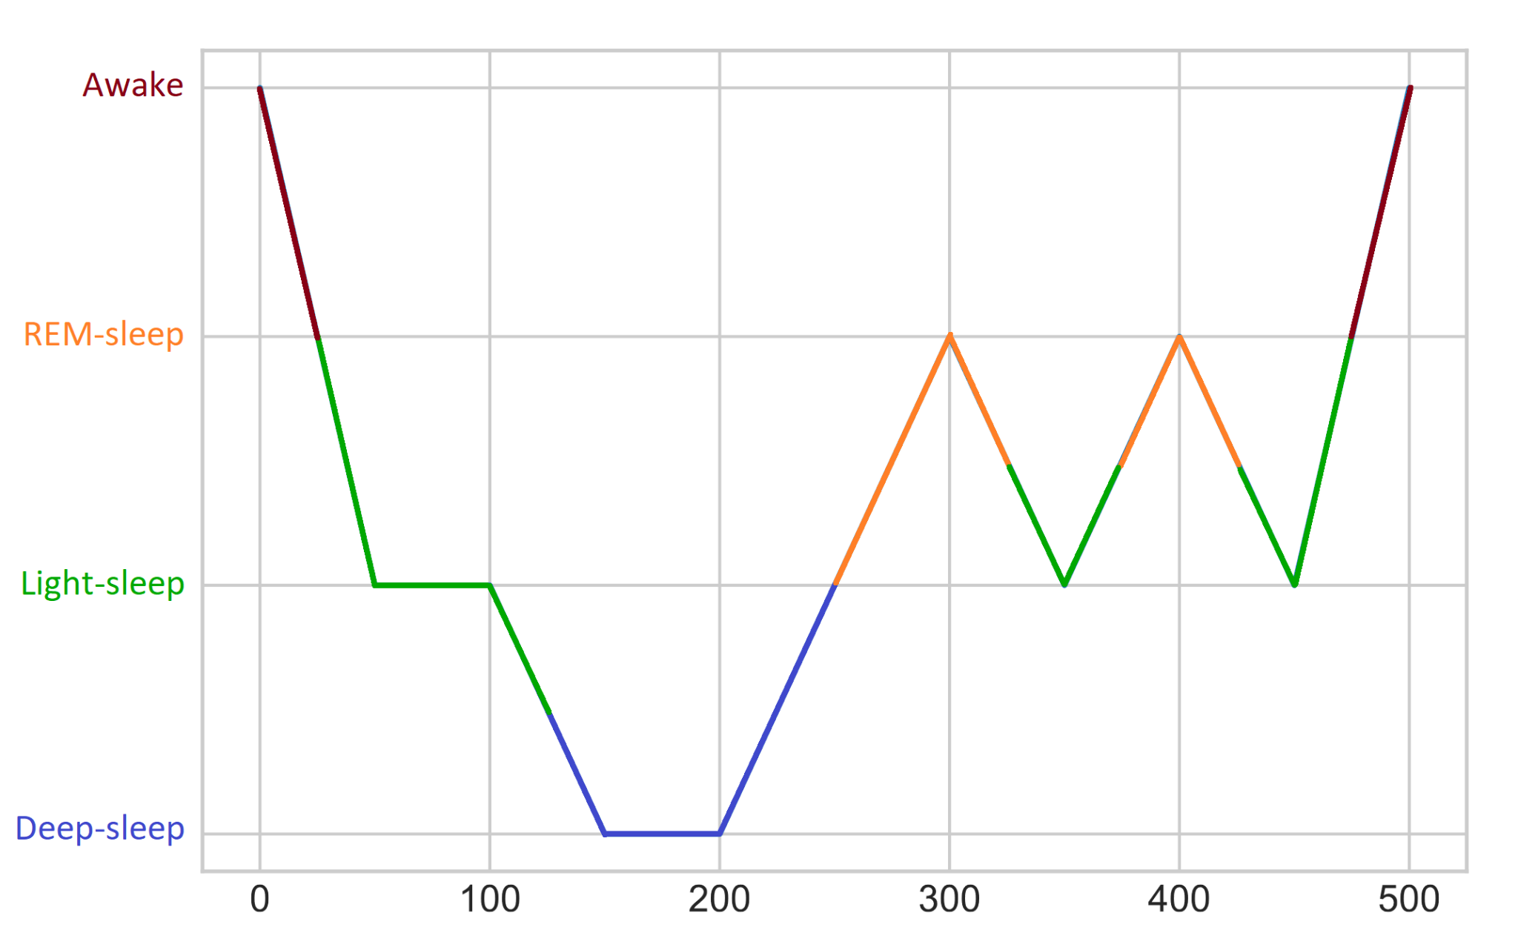

Our base idea was to play with the loss of references and the strange feelings which result from it, and we think it was a natural choice to twist some well-known melodies : the listener needs to have references before to lose them.

As dreams are really related to these strange feelings we decided to organize our composition around this theme, but we could have chosen another subject, such as psychedelics for instance, or do without. Yet we liked the idea very much, as it makes it more accessible to the general public and it makes interesting parallels, even though it restricts us a bit to keep the coherence.

At the beginning we wanted to go through a lot of sleep cycles to express a large diversity of feelings, but either the piece would have been too long or boring, or we would have to “rush” each phase. We chose this shape because it is close enough to the sleep phases proceeding in reality but not boring to be heard by the general public.

After hearing our composition matches our expectations quite well overall, the only point is that we would like it to go a bit more in depth with the emotions and symbolic behind the deep sleep and REM sleep and maybe audio edition would have strengthened the ambiance. The phases are a bit fast in their way to succeed to each other but they are individually understandable and we are happy with that.

We also showed our work to a few people and explained a bit what we’ve done, and after a couple of hearings they finally got into the ideas we wanted to share, so we are satisfied with the composition in general.

This project was truly interesting, as it made us experience a new way to conceptualize the means to create music. We all had previous experience in playing an instrument, but we never saw algorithms as a way to compose. Indeed, we learned to use this powerful tool and ended up with a composition which we would have never thinked about without this class. The method is actually unique and has its advantages : it becomes possible to compose really complex soundscapes or effects which are beyond our mastering, but the main drawback is that we lose the ability to play music ourselves and the direct link to the music we create. In any case it was an inspiring experience for us.

We are collectively satisfied with the piece we’ve created, but with more time to refine it we could have worked more deeply on the sound as a material to clarify its identity. For instance we would like to spend time on audio editing to improve the atmospheres we develop.